**ASSIGNMENT II**

**CODE FOR GMAIL LOGIN AND SIGNOUT:**

package TestNG;

import java.util.concurrent.TimeUnit;

import org.testng.annotations.Test;

import org.openqa.selenium.By;

import org.openqa.selenium.WebDriver;

import org.openqa.selenium.WebElement;

import org.openqa.selenium.chrome.ChromeDriver;

import org.openqa.selenium.support.ui.ExpectedConditions;

import org.openqa.selenium.support.ui.WebDriverWait;

import org.testng.annotations.Test;

public class NewTest4 {

**@Test(groups="Gmail")**

public void login()

{

WebDriver driver1; System.setProperty("webdriver.chrome.driver","C:\\Program Files\\Java\\jdk1.8.0_131\\chromedriver.exe");

driver1 = new ChromeDriver();

driver1.get("http://gmail.com") ;

**//enter email id**

WebElement element= driver1.findElement (By.xpath("//*[@id='identifierId']"));

element.sendKeys("karthigavallip@gmail.com");

**// click next button**

driver1.findElement(By.xpath(".//*[@id='identifierNext']/content/span")).click();

}

**//enter password**

driver1.manage().timeouts().implicitlyWait(5, TimeUnit.SECONDS);

WebElement element1= driver1.findElement (By.xpath(".//*[@id='password']/div[1]/div/div[1]/input"));

element1.sendKeys(“**********");

**// click next button**

driver1.findElement(By.xpath(".//*[@id='passwordNext']/content/span")).click();

}

**@Test (groups="Gmail")**

public void signout()

{

WebElement myDynamicElement = (new WebDriverWait(driver1, 15)).until(ExpectedConditions.presenceOfElementLocated(By.xpath(".//*[@id='gb']/div[1]/div[1]/div[2]/div[4]/div[1]/a/span")));

driver1.findElement(By.xpath(".//*[@id='gb']/div[1]/div[1]/div[2]/div[4]/div[1]/a/span")).click();

**//press signout button**

driver1.findElement(By.xpath(".//*[@id='gb_71']")).click();

}

**@Test(enabled=false)**

public void gmail()

{

System.out.println(“gmail was signed out”);

}

**}**

**XML CODE:**

<?xml version="1.0" encoding="UTF-8"?>

<!DOCTYPE suite SYSTEM "http://testng.org/testng-1.0.dtd" >

<suite name="Sample Suite">

<test name="testing">

<groups>

<run>

<include name="Gmail"/>

</run>

</groups>

<classes>

<class name="TestNG.NewTest4" />

</classes>

</test>

</suite>

**OUTPUT:**

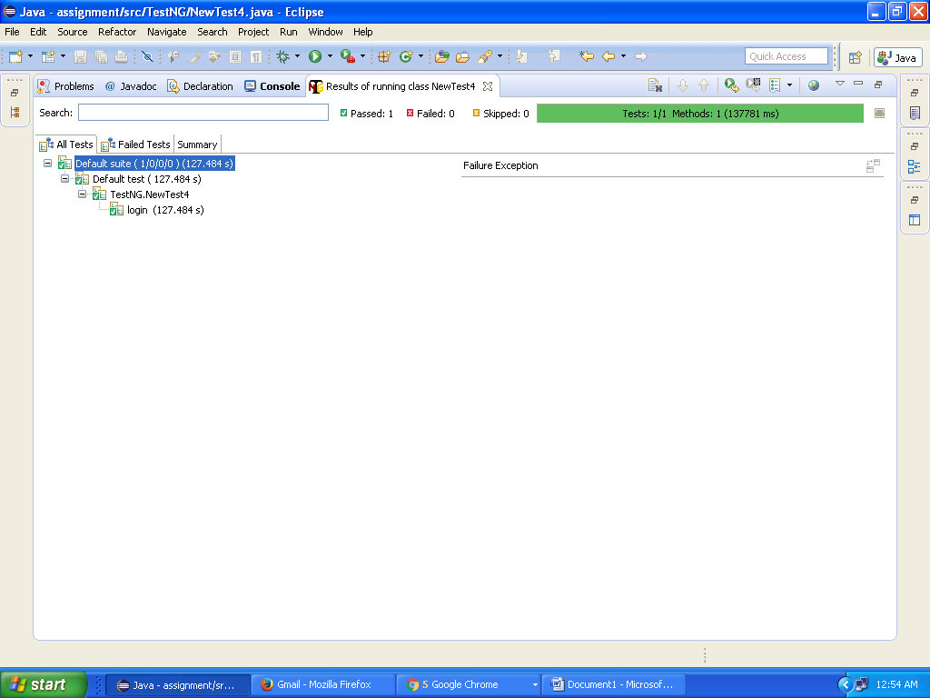

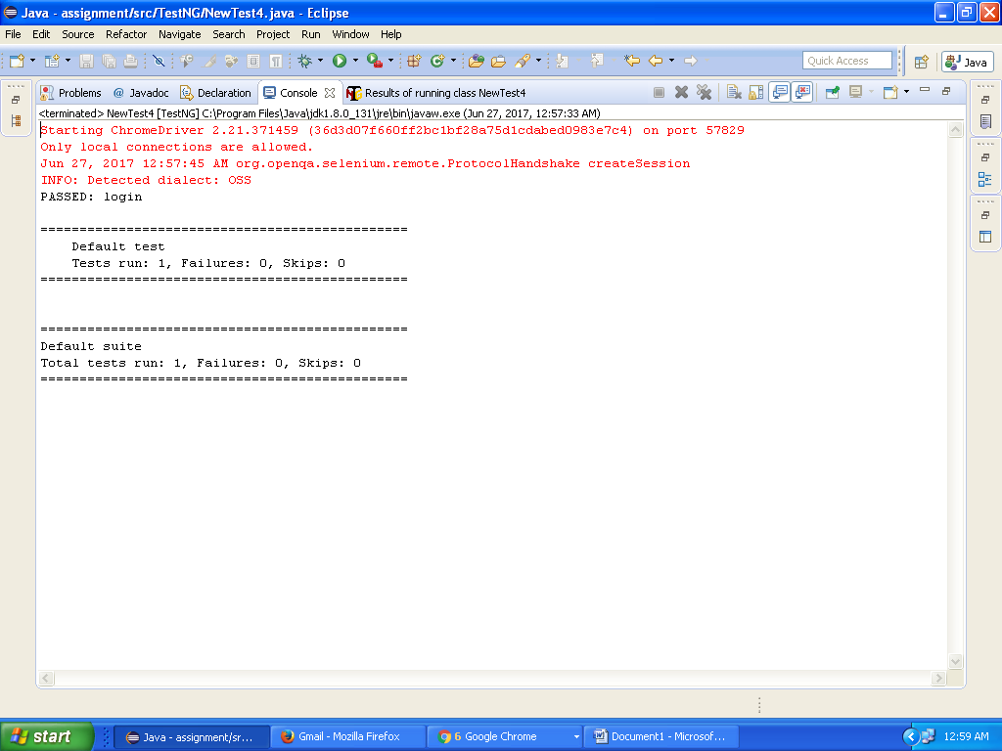

**TEST OUTPUT:**

